10.81: For rolling without slipping, the kinetic energy is 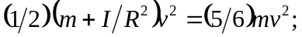 initially, this is 32.0 J and at the return to the bottom it is 8.0 J. Friction has done 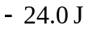 of work, 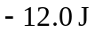each going up and down. The potential energy at the highest point was 20.0 J, so the height above the ground was 